Trends between US emissions and natural disasters

**Was there a rise in CO2 emissions in the United States based on the data we can find and collect?**

We were able to collect US emission data going as far back as 1960. Prior to that, we were unsure if CO2 emissions were collected so this set our data date range to be from 1960 to 2016. Within the date range we collected, we were able to determine that there was a steady rise in the CO2 that was being emitted into the atmosphere up until the year 2007. After that, we see a decline in the total amount of the emissions the United States produces each year.

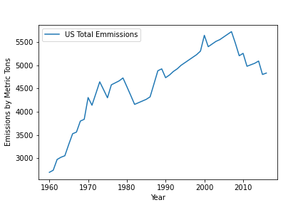

Figure 1 - US Emissions by Metric Tons

**Was there a rise in natural disasters?**

This question became a little trickier to answer because after we started digging into the data more, we learned that up until 1992, the only natural disasters that were recorded were thunderstorms, tornados, and hail. You can see in our graph below, that once the year hits 1993, we begin our significant rise in natural disasters. This is because the NOAA (National Oceanic and Atmospheric Administration) began recording 44 other natural disasters. This includes disasters such as hurricanes, blizzards, coastal floods and more. As you can see, there is a slight general increase in our events prior to 1992, but then with the new included types of disasters, we can see there is general increase is each year until 2012. After 2011, we see a general decrease in our event each year.

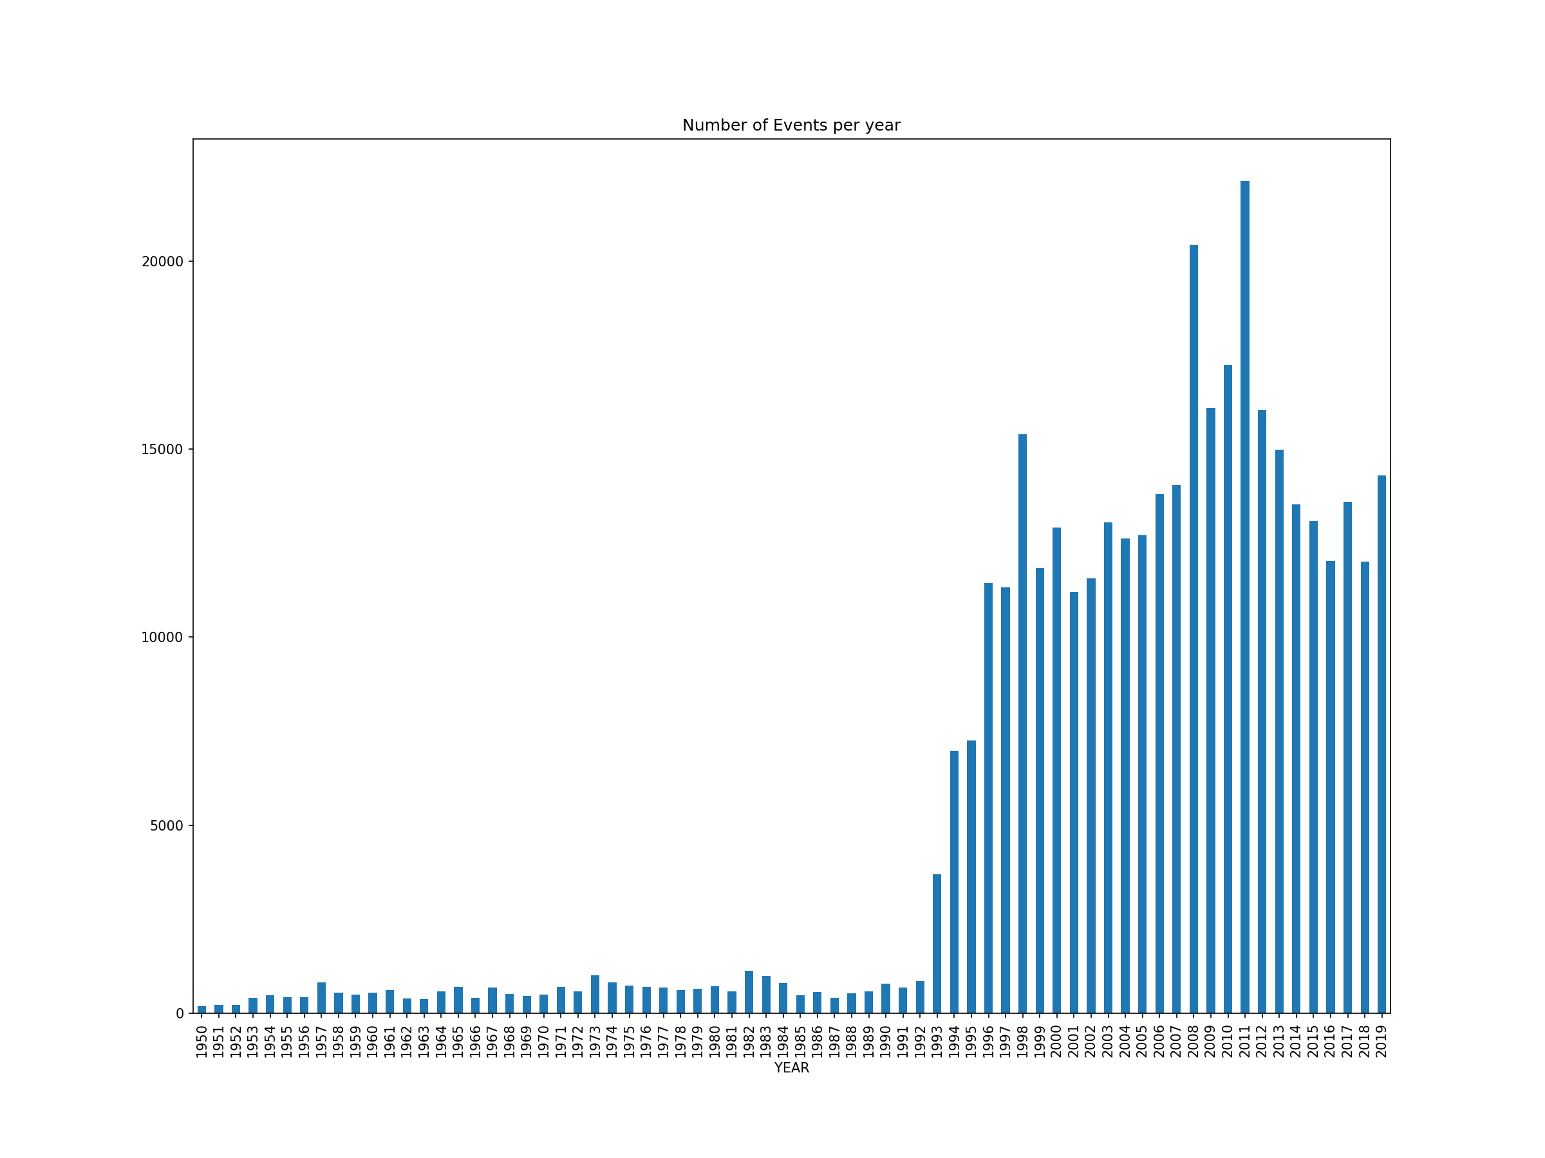

Figure 2 All disaster events

We also created a separate graph that will display only tornado, thunderstorm/wind, and hail events from 1950 until 2019. In figure 3, you can see that there was in increase in the events recorded as well.

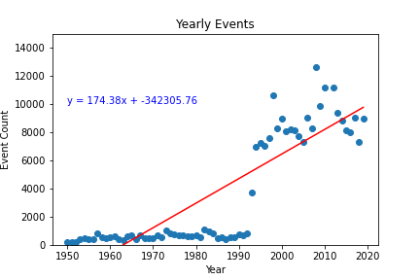

Figure 3 all Thunder/Wind, Hail, Tornado events

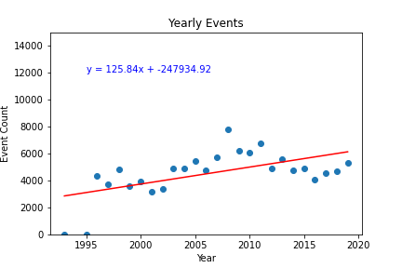

Figure This graphs all events from 1993 and on

3. With the data we collected, is there a rise in financial damages from natural disaster

Based on the data we can see in Figures 5 and 6, we can see there is in fact a general trend of natural disasters causing more damage. We did compensate for inflation in these graphs because our original data source did not take that factor into account. 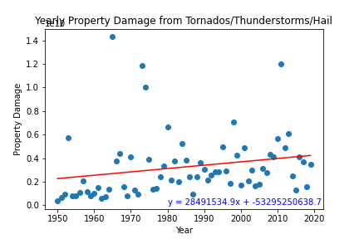

Figure Exclusively Thunder, Wind, Hail, Tornado

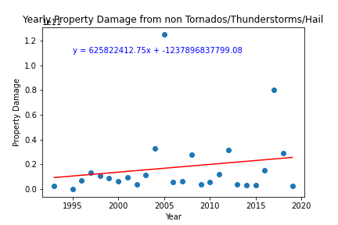

Figure other categories property damage

4. Can we predict financial impact disasters in the future?

With the general trend displayed in figures 4 and 5, we can hypothesis that this trend that has occurred for the last twenty years will continue. Using the formula displayed on figure 6, we can make estimates for 2025, 2030, and 2035.

|  |  |
| --- | --- |
| Year | Total Property damage |
| 2025 | $ 29393548019.67 |
| 2030 | $ 32522660083.42 |
| 2035 | $ 35651772147.17 |